Project Design Phase-II
Technology Stack (Architecture & Stack)

Date | 30 September 2026
Team ID
Project Name | Script-Controlled ACL – Restrict Record Access Based on Field Value
Maximum Marks | 4 Marks
Technical Architecture:
The Deliverable shall include the architectural diagram as below and the information as per the table1 & table 2
Example: Script-controlled ACL for restricting record access in ServiceNow
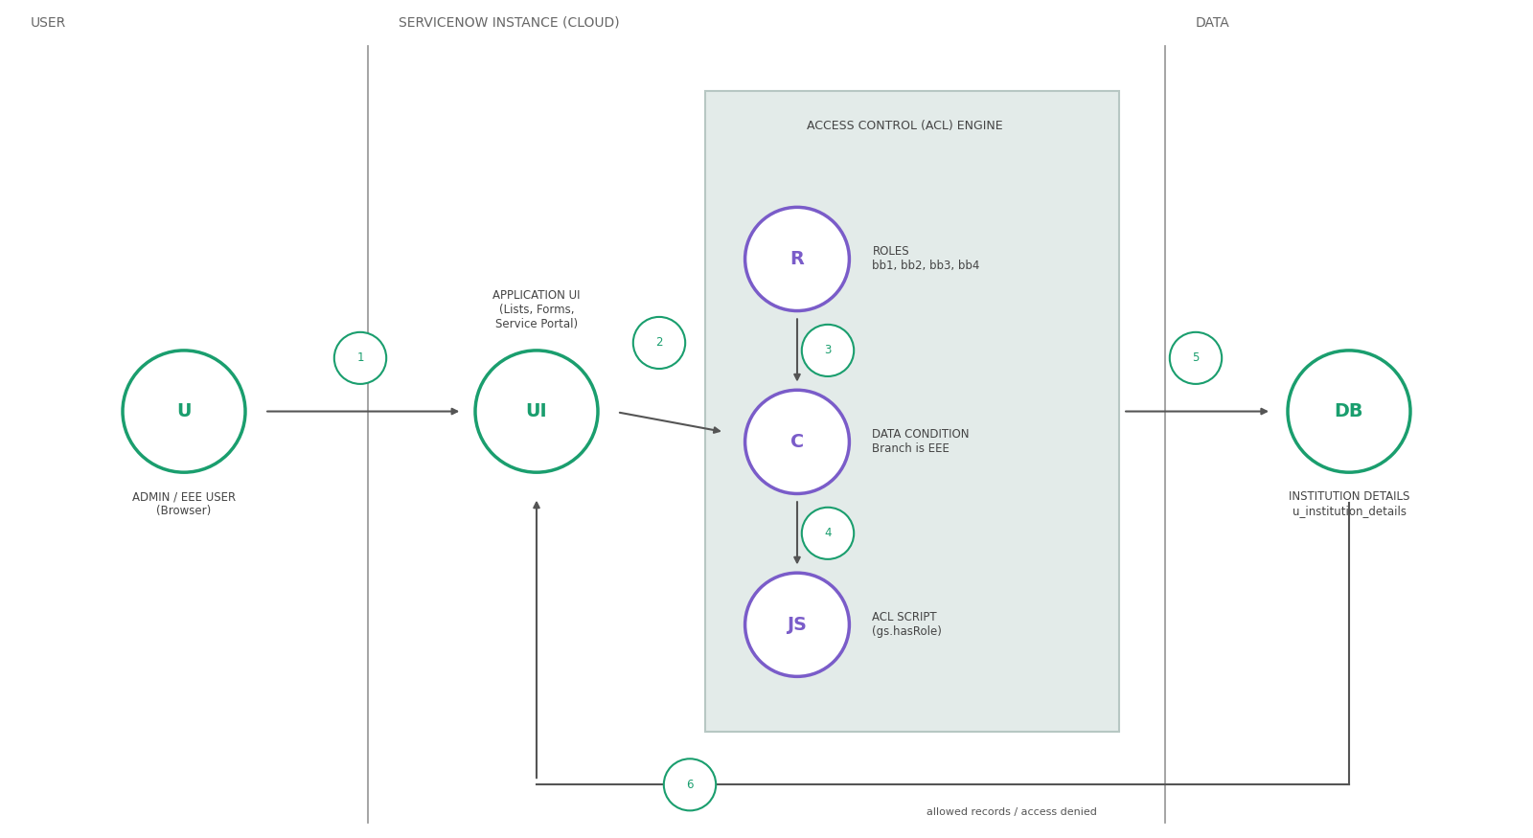 | Guidelines:  - Include all the processes (As an application logic / Technology Block)  - Provide infrastructural demarcation (Local / Cloud)  - Indicate external interfaces (third party API’s etc.)  - Indicate Data Storage components / services  - Indicate interface to machine learning models (if applicable)

Table-1 : Components & Technologies:
S.No | Component | Description | Technology
1. | User Interface | Admin and EEE users interact with the ServiceNow web UI: Application Navigator, User Administration, lists, forms and Service Portal | ServiceNow Now Platform UI in a web browser, Service Portal
2. | Application Logic-1 | Users and roles creation: create the EEE User and the roles bb1, bb2, bb3, bb4, then assign the roles to the user | ServiceNow User Administration (Users, Roles)
3. | Application Logic-2 | Table creation: custom table Institution Details (u_institution_details) with its fields and branch records | ServiceNow System Definition (Tables)
4. | Application Logic-3 | Script-controlled ACL logic: Read ACL with role bb1, data condition Branch is EEE and a script that allows admin and bb1 users and denies all others; Create, Write and Delete ACLs with roles bb2, bb3 and bb4 | ServiceNow Access Control (ACL), JavaScript (gs.hasRole)
5. | Database | Data type and configuration: Student Roll Number (Auto Number), Student Name and Faculty Name (Reference – User), Branch (Choice: ECE, EEE, CSE), Email and Phone Number (String), Description (Multi String) | ServiceNow table u_institution_details
6. | Cloud Database | Database service on cloud: the records are stored in the database of the ServiceNow cloud instance | ServiceNow instance database
7. | File Storage | No separate file storage is required; all data is stored as table records | Not applicable
8. | External API-1 | No external API is used in this solution | Not applicable
9. | External API-2 | No external API is used in this solution | Not applicable
10. | Machine Learning Model | No machine learning model is used in this solution | Not applicable
11. | Infrastructure (Server / Cloud) | Application deployment on Cloud: the ACLs are configured on a ServiceNow instance using admin access (with the security_admin role elevated)  Local Server Configuration: Not required; the instance is accessed through a web browser  Cloud Server Configuration: ServiceNow cloud instance | ServiceNow cloud instance

Table-2: Application Characteristics:
S.No | Characteristics | Description | Technology
1. | Open-Source Frameworks | No open-source framework is used; the solution relies on built-in ServiceNow features | ServiceNow platform features, JavaScript (ACL script)
2. | Security Implementations | Role-based access control: Read, Create, Write and Delete ACLs with roles bb1 to bb4, the data condition Branch is EEE and a script that denies users without the required role; security_admin is elevated to create ACLs; access is tested by impersonating users | ServiceNow ACLs, Roles, security_admin role, gs.hasRole
3. | Scalable Architecture | Access rules are defined at table level, so more branches, roles or operations can be added with extra data conditions, roles or ACLs | ServiceNow table-based ACLs
4. | Availability | The application runs on a cloud-hosted ServiceNow instance and the ACLs are active, so they are checked every time a record is accessed | ServiceNow cloud instance
5. | Performance | The ACL script only checks roles, so access decisions are quick when a list or form is opened | ServiceNow ACL engine, gs.hasRole
References:
https://c4model.com/
https://developer.ibm.com/patterns/online-order-processing-system-during-pandemic/
https://www.ibm.com/cloud/architecture
https://aws.amazon.com/architecture
https://medium.com/the-internal-startup/how-to-draw-useful-technical-architecture-diagrams-2d20c9fda90d

